Try this!

4
1
2
3
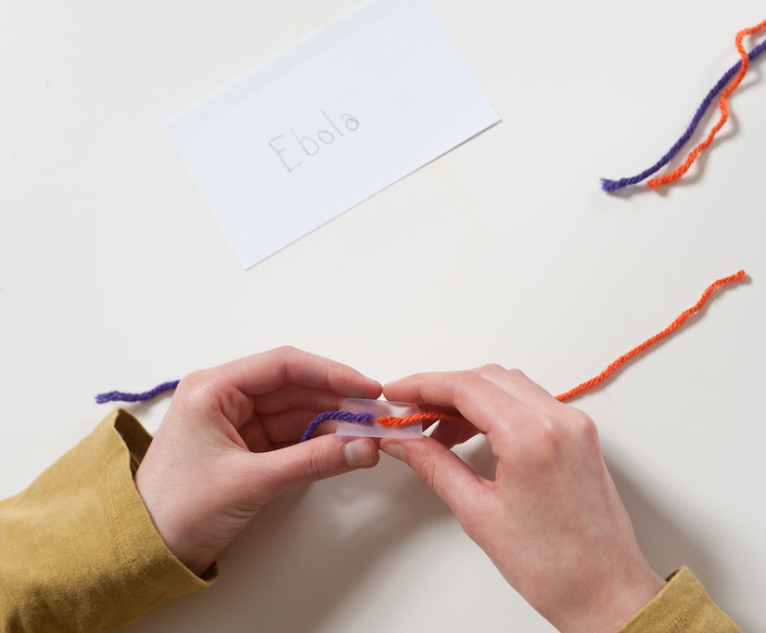
1. Think of a disease that you want to cure and write it on an index card. You’re going to make a model of a virus to help deliver a cure for that disease. To do this, you’ll build special instructions (engineered genetic material) and insert them into a container (a viral capsid).
2. Make engineered genetic material using yarn. Take two pieces of yarn: one purple and one orange. Each piece of yarn represents a strand of DNA that carries a specific set of genetic instructions (or genes).
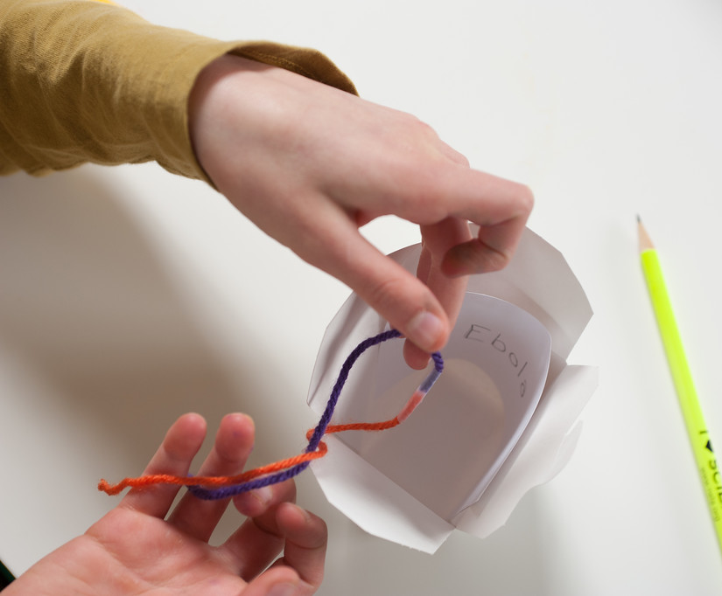
Use scissors to snip each strand of yarn into two pieces. Then use tape to attach a purple and an orange piece of yarn together. This “engineered genetic material” will provide instuctions for how to cure your disease.

3. Place the strand of engineered material into a takeout box along with your index card. The takeout box represents the capsid, or exterior shell, of a virus. You’re making a model delivery system to help transport your cure.
4. On a sticky note, write down where in the body this cure should go. Use more sticky notes to write down specific instructions for your modified virus to follow. Attach them all to the takeout box.

Talk about it…
How did you choose which disease you wanted to cure?
Is it surprising to think about using a virus to treat a disease? How could you test your cure to be sure it was as safe as possible?
Can you imagine other uses for “re-programming” viruses, beyond fighting disease?

Synthetic biologists solve problems by applying engineering principles to the life sciences.

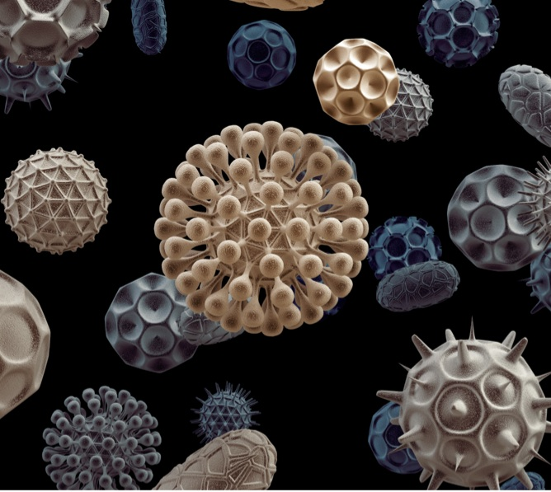
Researchers in the field of synthetic biology are engineering viruses to help treat diseases. It may seem strange to use viruses to treat disease, since we usually think of a virus as something that makes us sick, but scientists are taking advantage of the way viruses work to make them do helpful things.
Viruses have an external capsid, which is a protective protein shell that acts as a container. Inside the capsid is genetic material (either DNA or RNA). Viruses replicate by inserting their genetic material into another organism. In modified viruses, harmful genetic material is replaced with genetic information that is “programmed” to do beneficial things.
Viruses come in many different shapes. They replicate by invading living cells.

Someday it may be possible to engineer viruses to detect and destroy tumor cells in patients with cancer. They might also instruct cells to produce proteins or enzymes that the body needs to be healthy, such as insulin for people with diabetes.

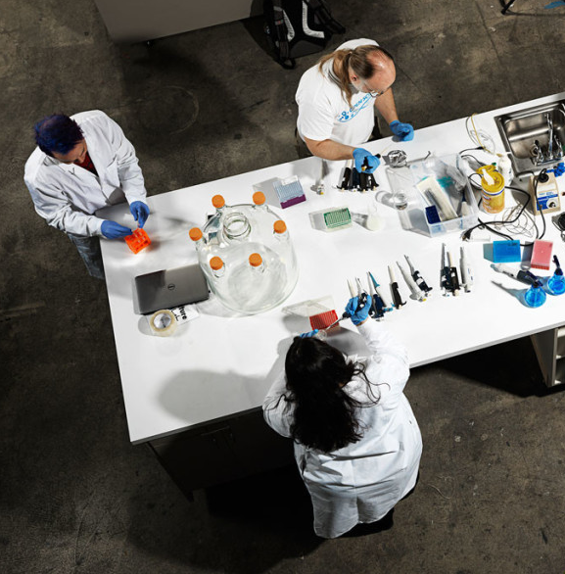
Synthetic biology benefits from many voices. People participate from many different fields, including art, science, engineering, public policy, and political science. Synthetic biologists design, build, and test new organisms. This work can take place in universities, companies, and community DIY (do-it-yourself) labs.
Even if you’re new to the ideas in synthetic biology, your opinions can shape the development of its tools and applications. How do you think synthetic biology technologies should be regulated or controlled?
Community bio spaces allow many different people to experiment with the tools and techniques of synthetic biology.

